# **Class 1 Gated Recurrent Unit | Deep Learning | GRU**

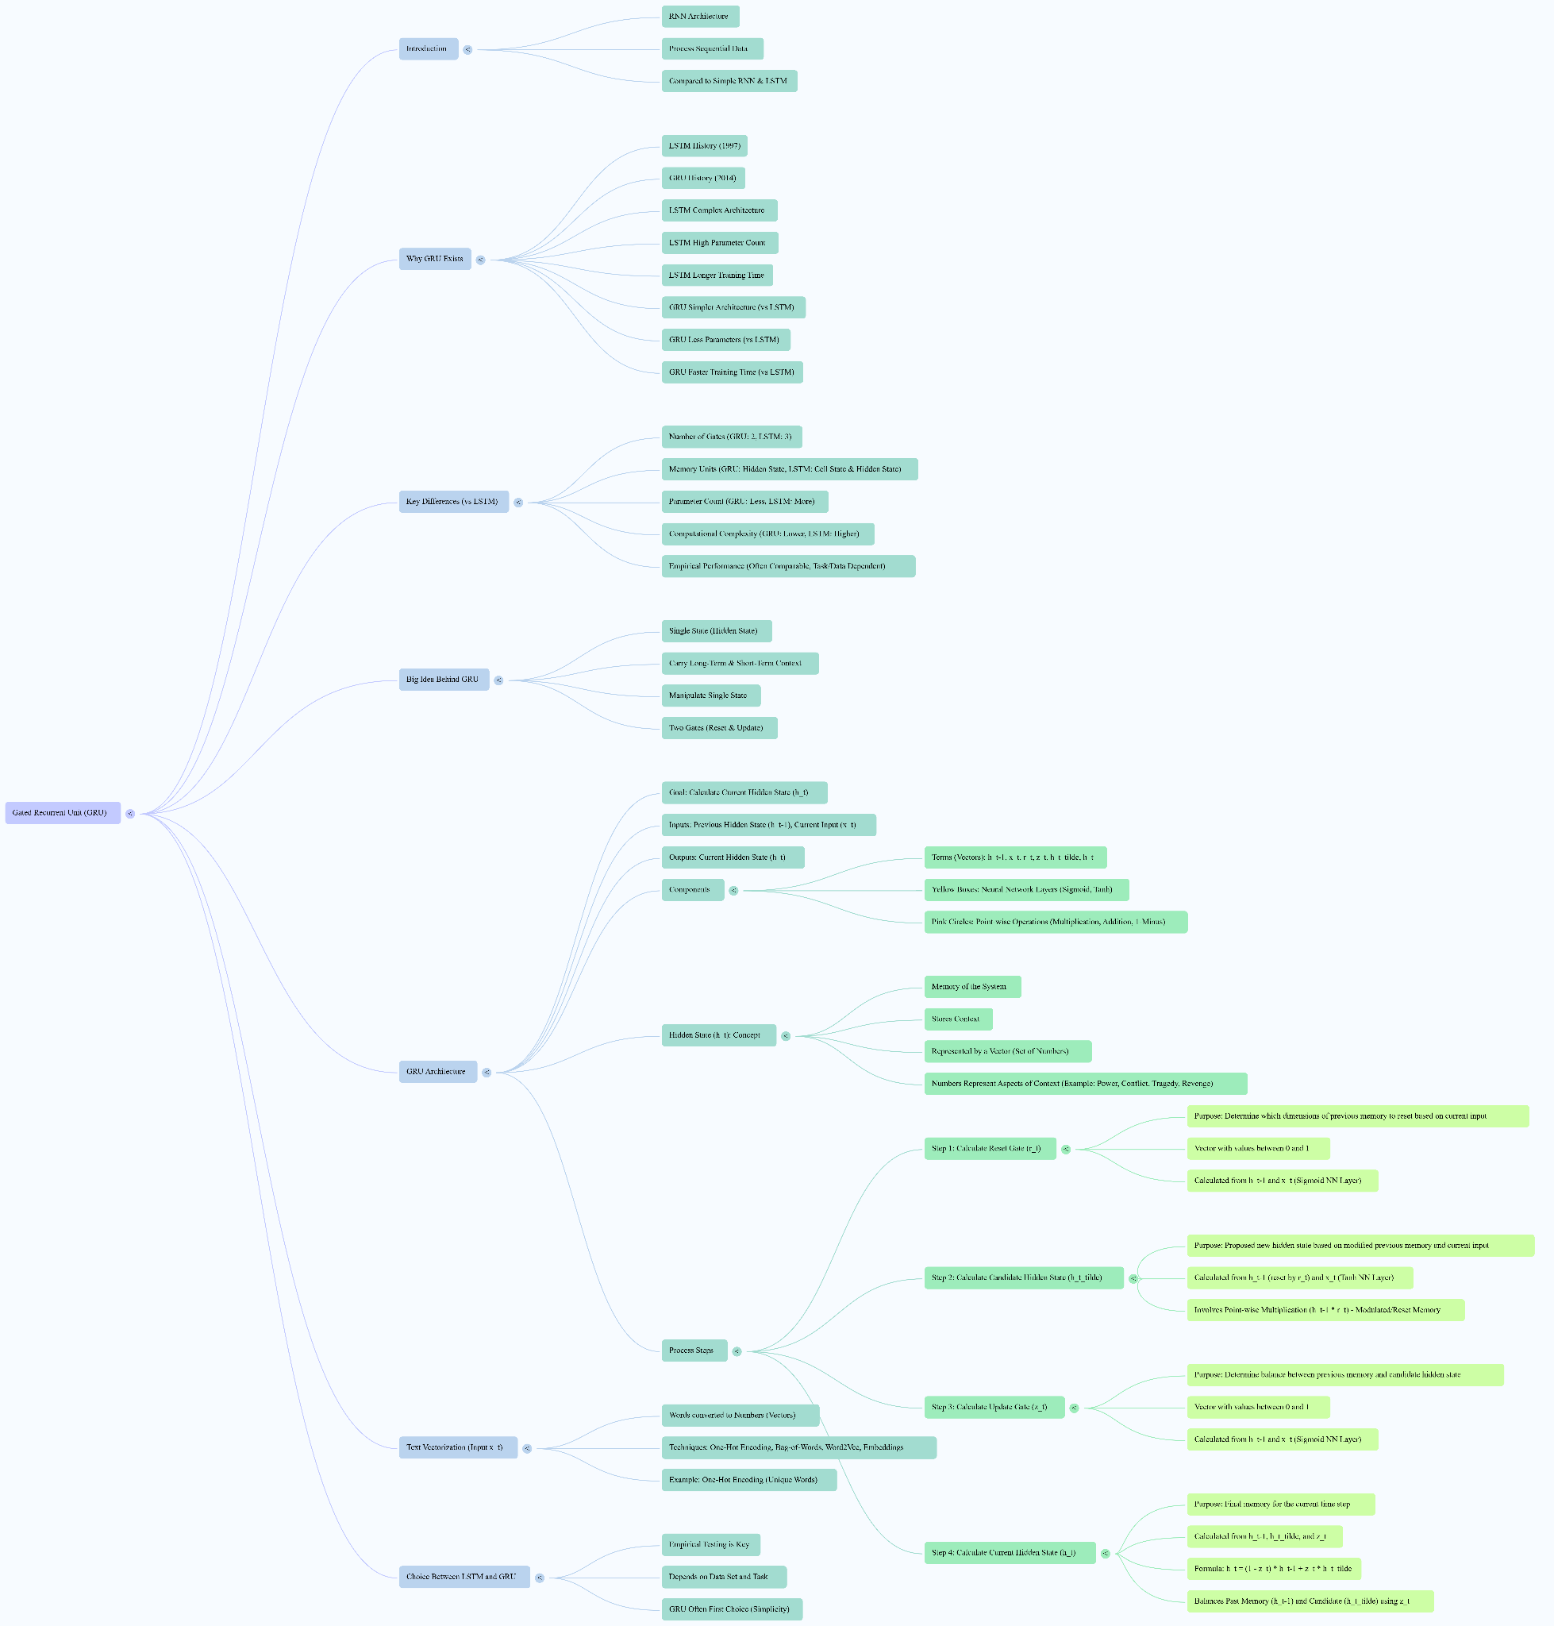

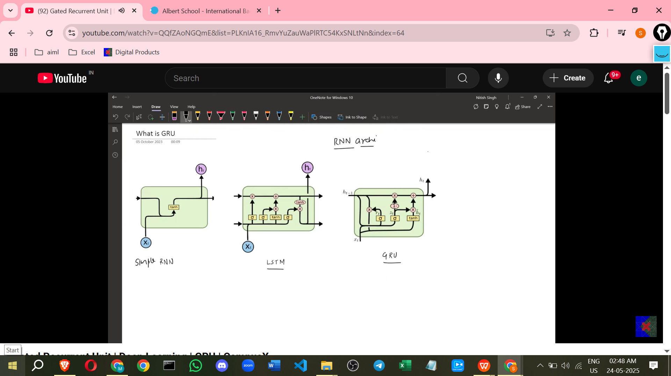

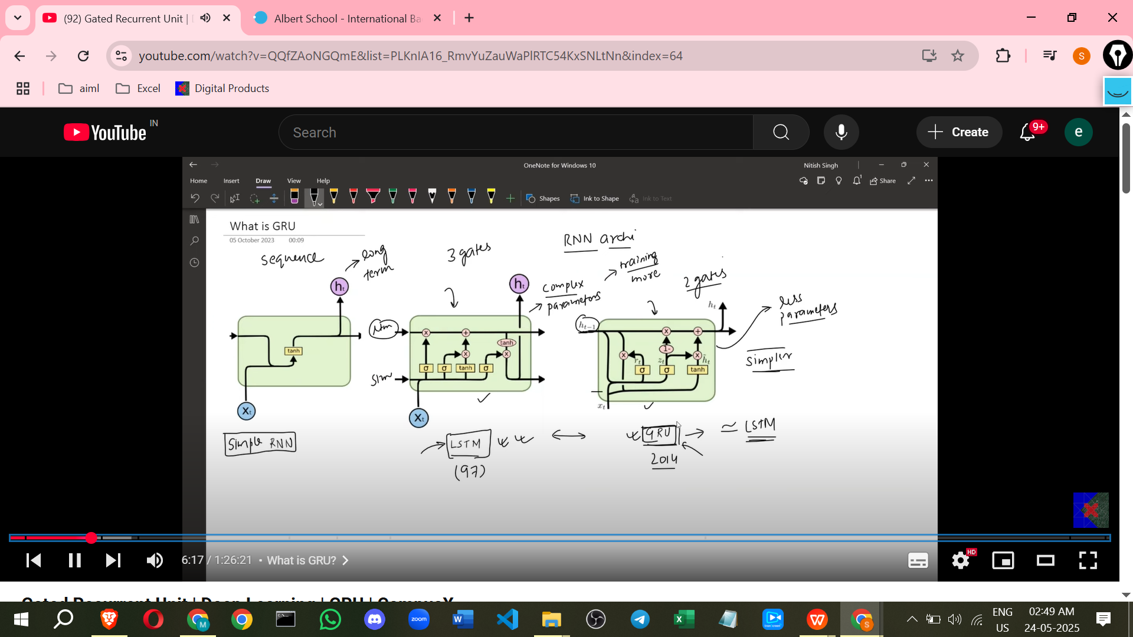

Here are some notes on Gated Recurrent Units (GRUs) based on the source provided, including some additional points to help clarify the concepts.

**Introduction to GRUs**

* GRUs are a type of Recurrent Neural Network (RNN) architecture.
* Like simple RNNs and Long Short-Term Memory (LSTM) networks, they are used to process sequential data.
* GRUs were developed more recently than LSTMs, appearing in 2014 compared to LSTMs in 1997.

**Why GRUs Exist**

* Simple RNNs have a major flaw: when processing very long sequences (like a long sentence), they struggle to retain long-term context due to **vanishing and exploding gradient problems**.
* LSTMs were introduced to solve these gradient problems and can retain long-term context. However, LSTMs have a relatively **complex architecture** and a **high number of parameters**.
* A high number of parameters in a neural network architecture means that training, especially on large datasets, can take a significant amount of time.
* GRUs exist to address this problem by offering a **simpler architecture** with **fewer parameters** compared to LSTMs, which leads to **less training time**.

**Key Features of GRUs**

* **Simpler Architecture**: GRUs are considered simpler in architecture than LSTMs.
* **Fewer Gates**: LSTMs have three gates (Forget Gate, Input Gate, Output Gate), while GRUs have only **two gates**: the **Reset Gate** and the **Update Gate**.
* **Single Memory Unit**: Unlike LSTMs, which maintain separate Cell State and Hidden State, GRUs use only a **single hidden state** to carry both long-term and short-term context.
* **Comparable Performance**: Despite having a simpler architecture and fewer parameters, the performance of GRUs is **comparable to LSTMs**. Empirically, GRUs have been shown to **outperform LSTMs on certain datasets or problems**, although this is not universally true.
* **Trade-offs**: Choosing between an LSTM and a GRU often requires **empirical testing** to see which performs better for a specific dataset and task. However, GRUs are often a **first choice** when starting due to their simplicity.

**The "Big Idea" Behind GRUs**

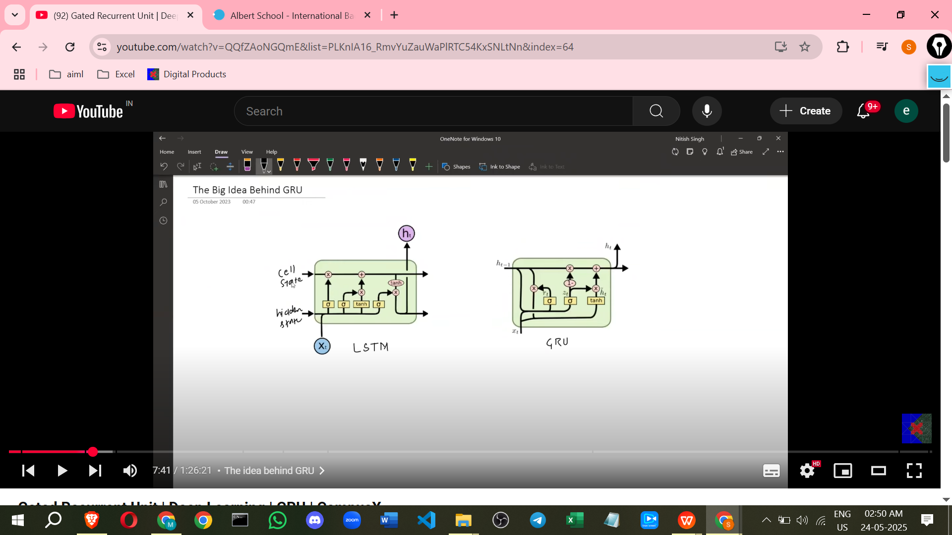

* The core idea of GRUs is the ability to carry both **long-term context and short-term context** using a **single state** (the hidden state), eliminating the need for separate states as in LSTMs.
* The two gates (Reset and Update) are responsible for **manipulating this single hidden state** to control how information flows from one time step to the next.

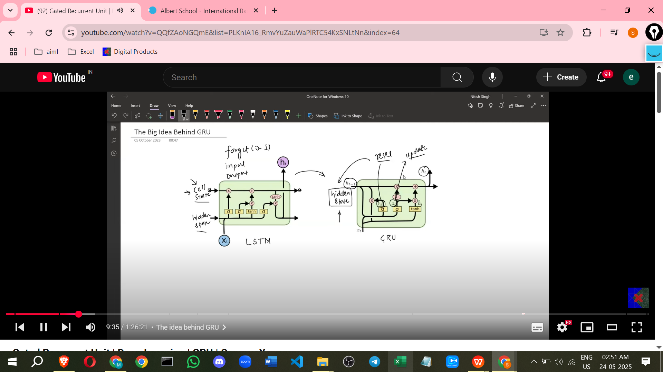

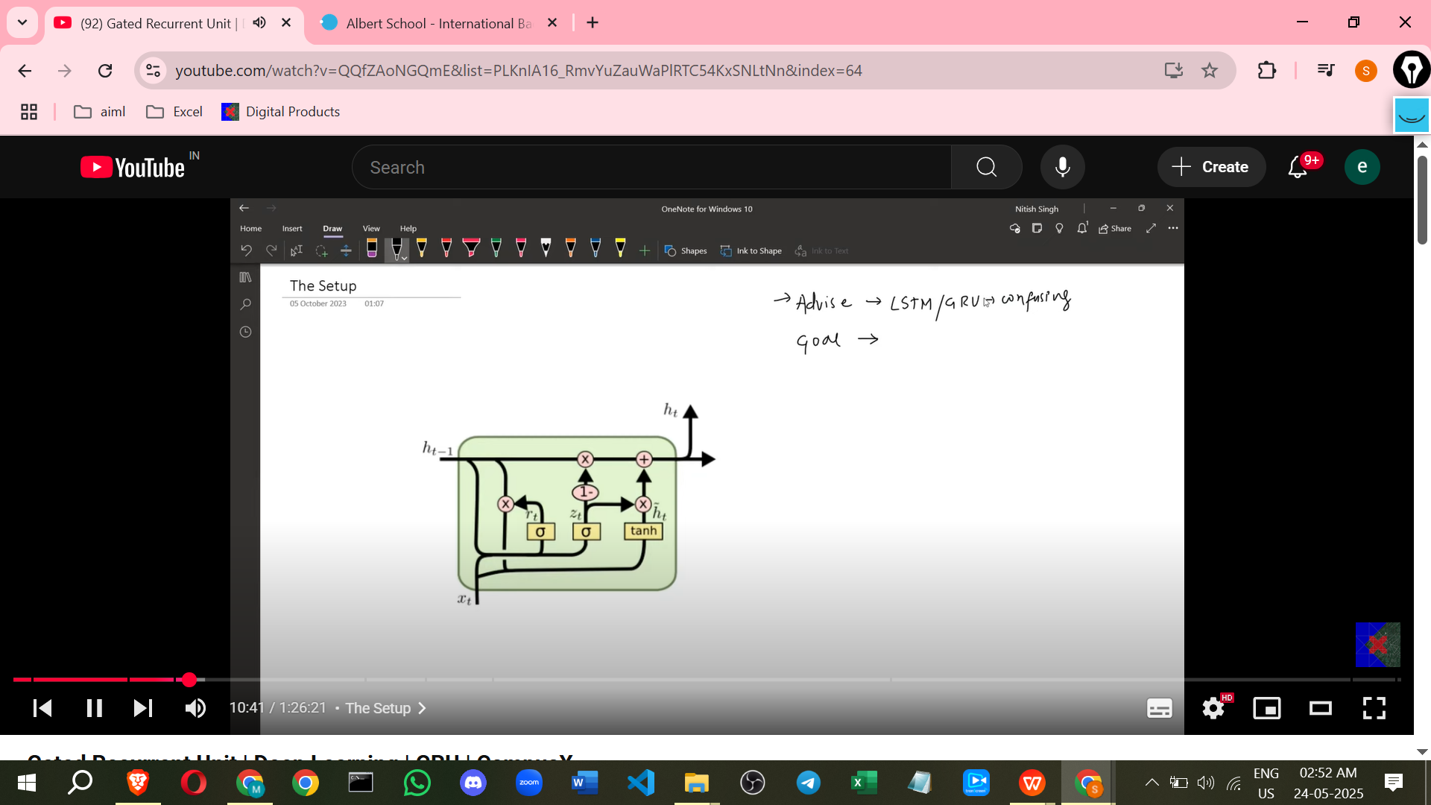

**Architecture and Goal**

* The main goal of the GRU architecture for any time step *t* is to take two inputs: the **previous hidden state (Ht-1)** and the **current input (Xt)**, and calculate the **current hidden state (Ht)**.
* This process of calculating Ht from Ht-1 and Xt is divided into four main steps.

**Components of the GRU Architecture**

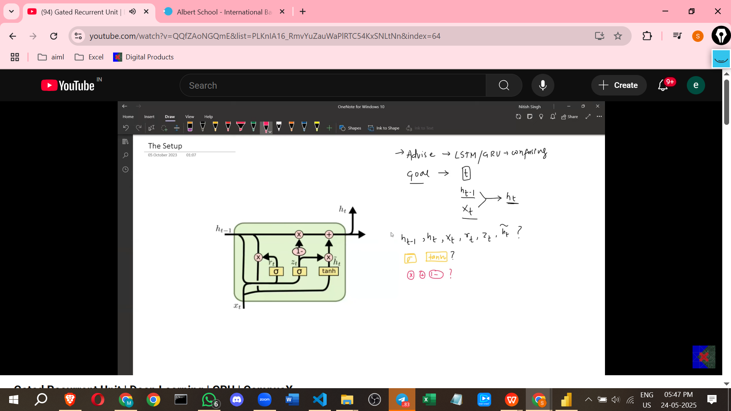

* **Vectors**: Various terms in the diagram represent vectors (sets of numbers).
  + **Ht-1**: Previous Hidden State (memory/context from the previous time step).
  + **Ht**: Current Hidden State (memory/context for the current time step).
  + **Xt**: Current Input (the data being processed at the current time step, e.g., a word vector).
  + **Rt**: Reset Gate vector.
  + **Zt**: Update Gate vector.
  + **Ht-tilde (or bar)**: Candidate Hidden State or Candidate Memory (a proposed new state).
  + **Dimension Consistency**: Except for Xt, all these vectors (Ht-1, Ht, Rt, Zt, Ht-tilde) always have the **same dimension**. This dimension is usually a hyperparameter, often related to the number of nodes in the neural network layers.

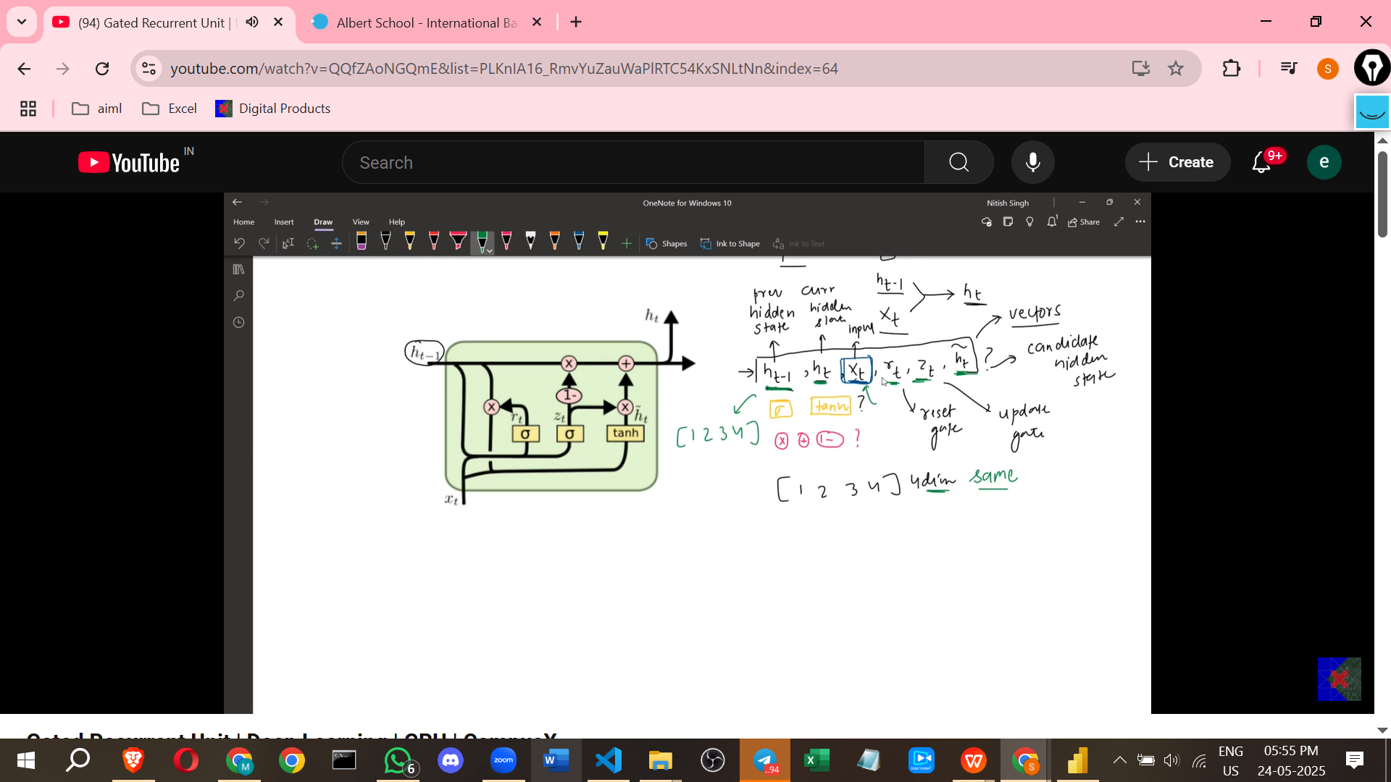

* **Neural Network Layers**: The yellow boxes represent fully connected neural network layers with specific activation functions.
  + Layers computing gates (Rt, Zt) typically use the **sigmoid** activation function, which outputs values between 0 and 1.
  + The layer computing the candidate hidden state (Ht-tilde) typically uses the **tanh** (hyperbolic tangent) activation function.
  + All these neural network layers within a single GRU cell have the **same number of nodes**.

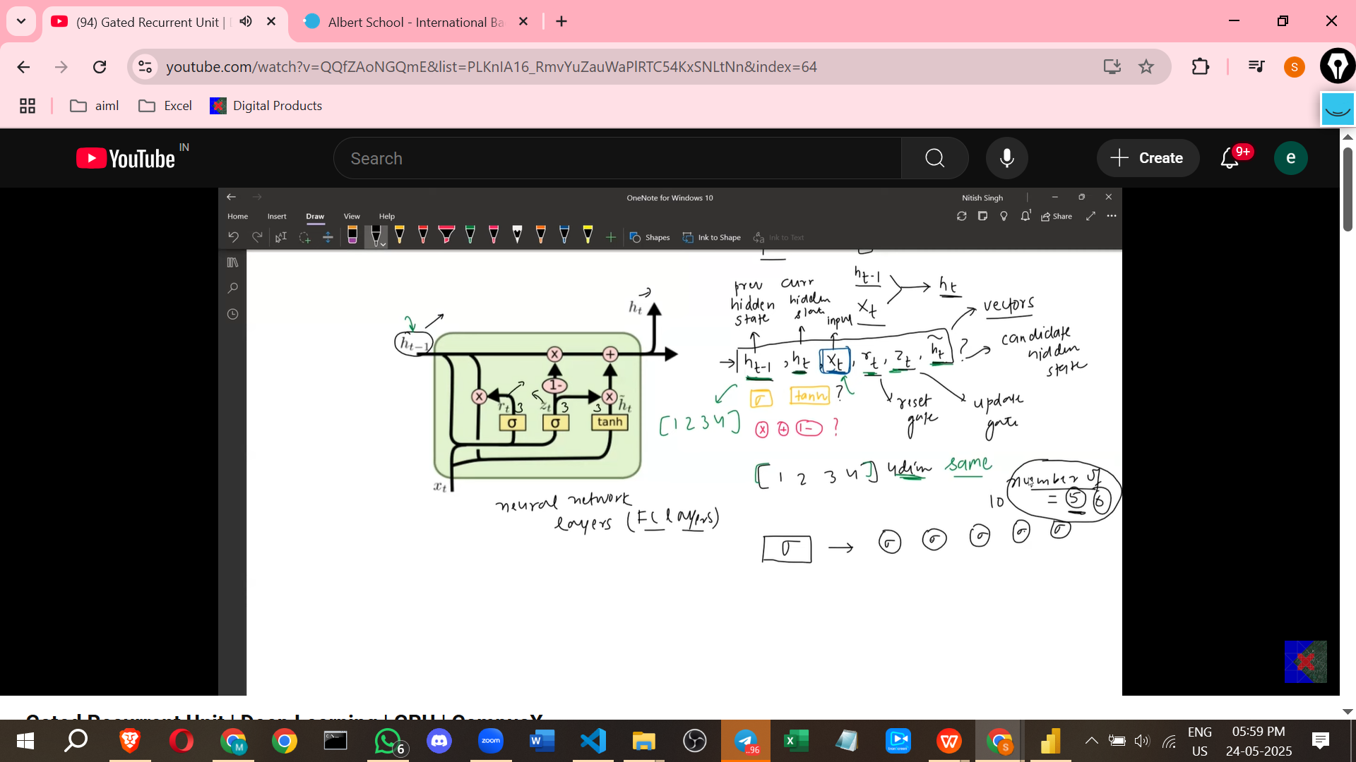

* **Point-wise Operations**: The pink symbols represent element-wise mathematical operations on vectors.
  + **Cross (X)**: Point-wise or element-wise multiplication.
  + **Plus (+)**: Point-wise or element-wise addition.
  + **One Minus (1-)**: Point-wise subtraction of each element from 1.

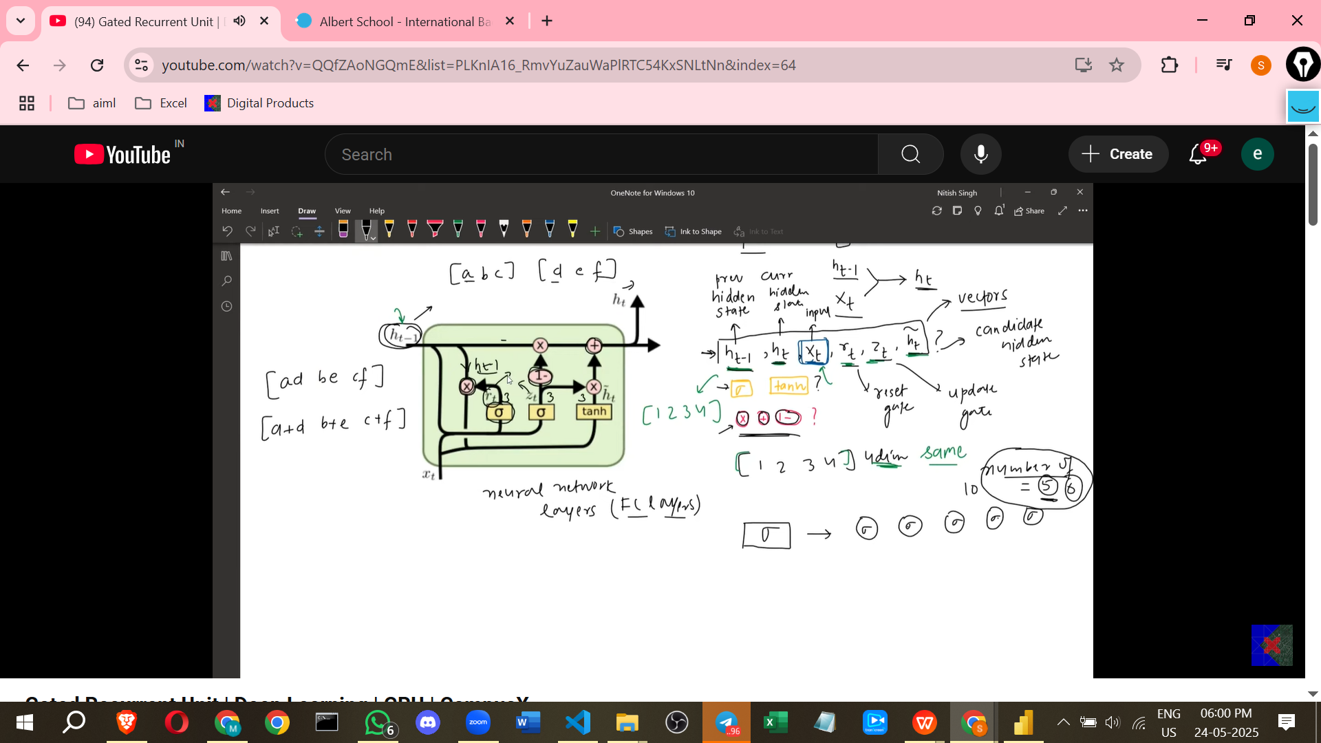

**INPUTS**

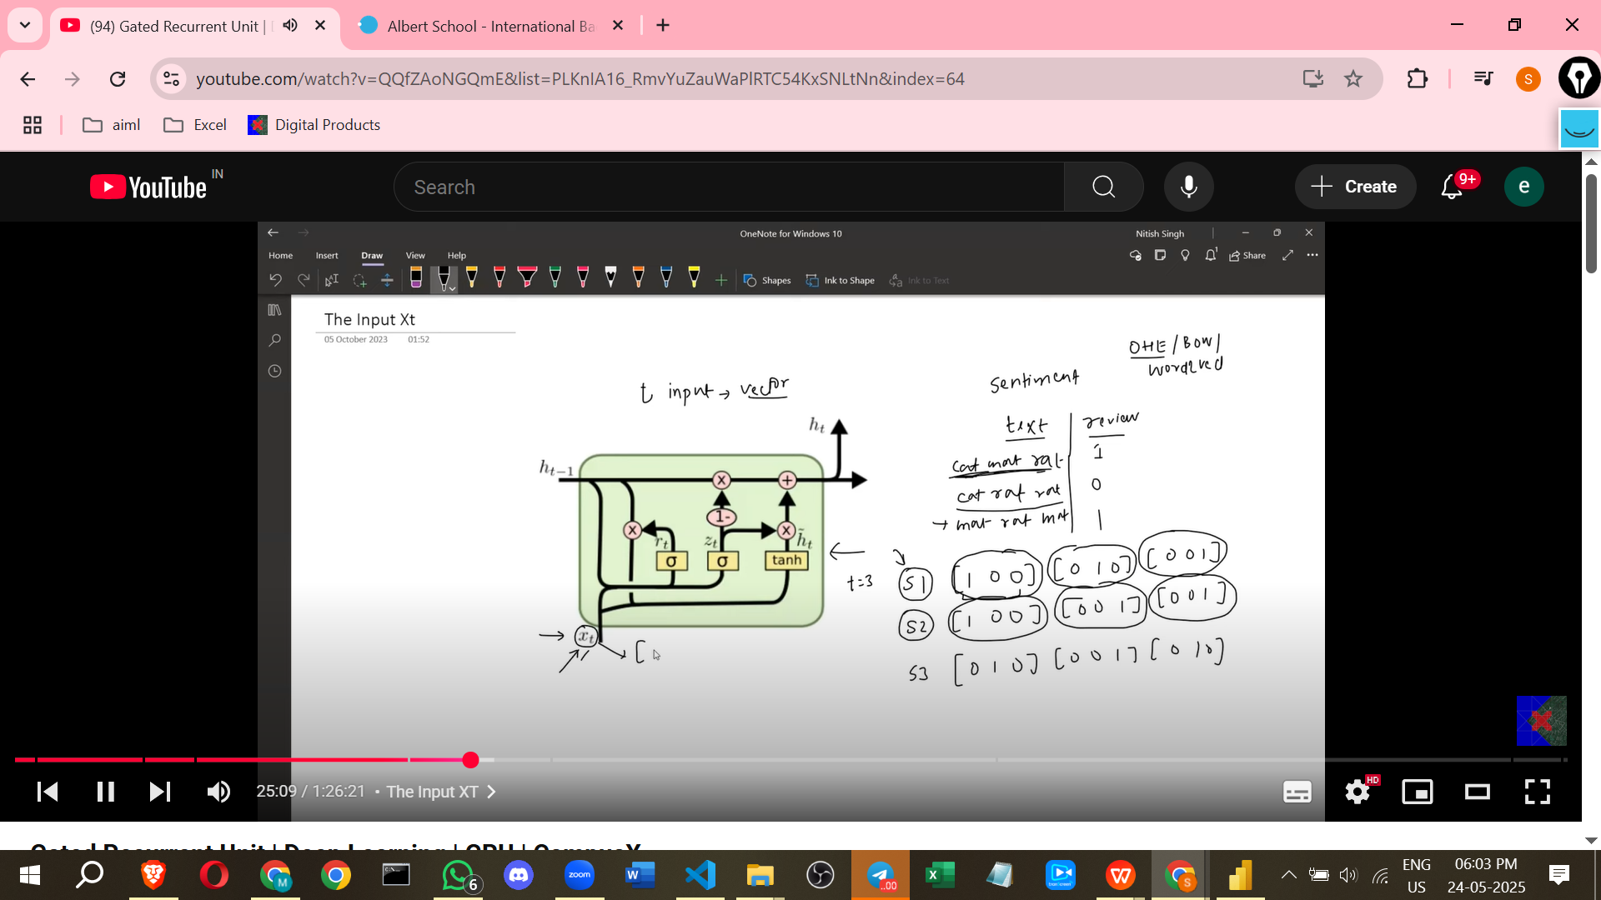

**PROCESS TO FIND THE HT**

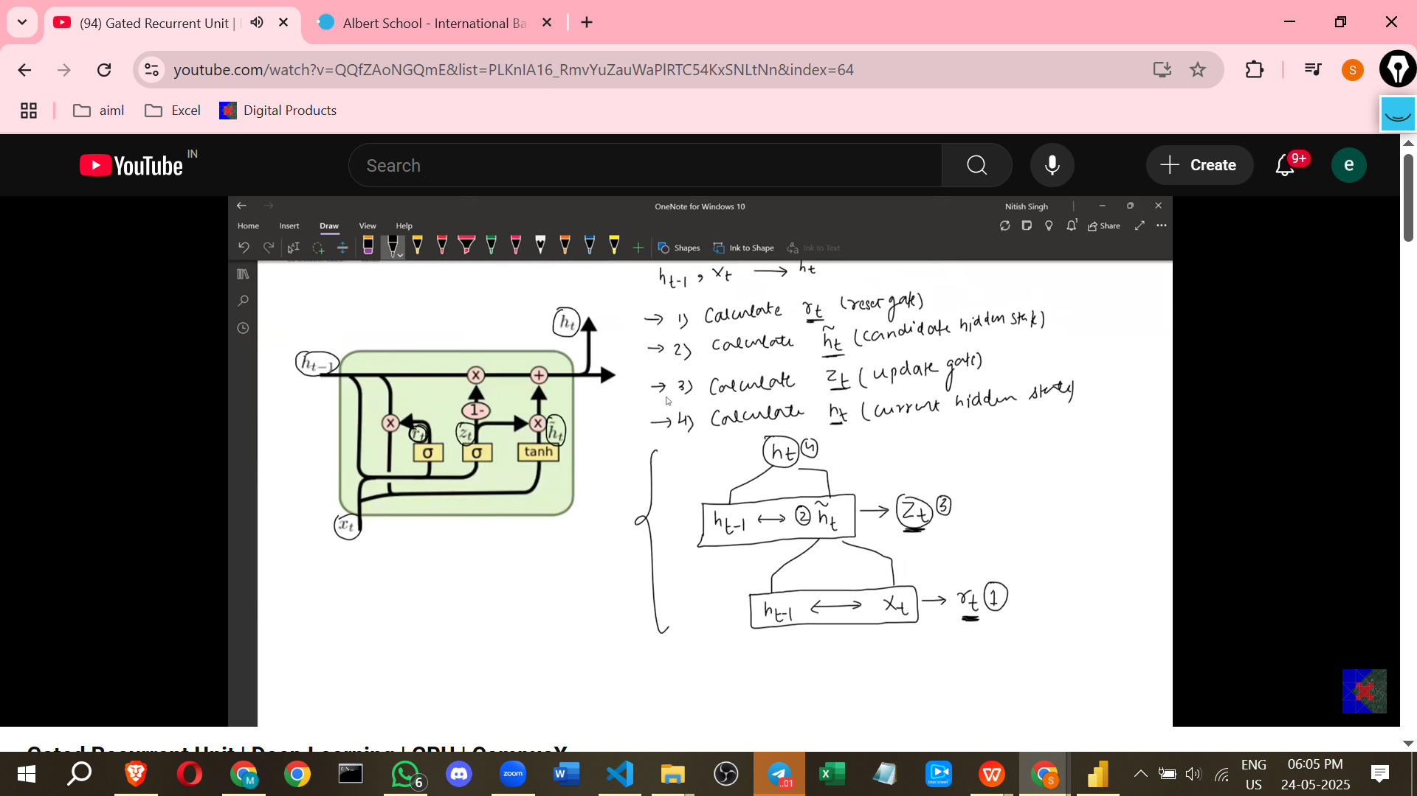

**The Hidden State as Memory/Context**

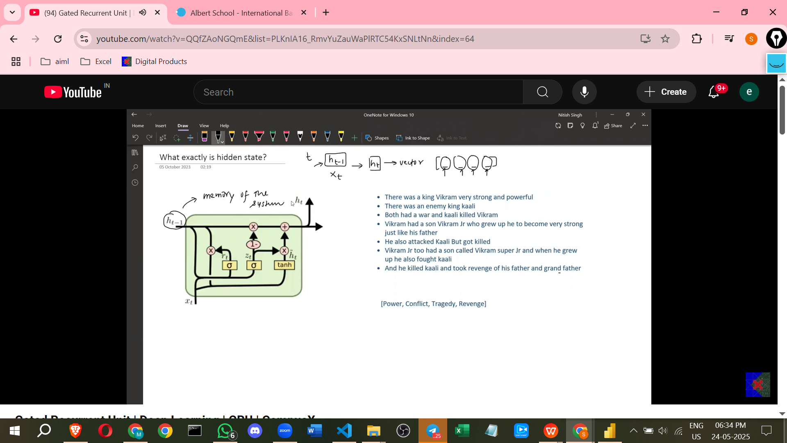

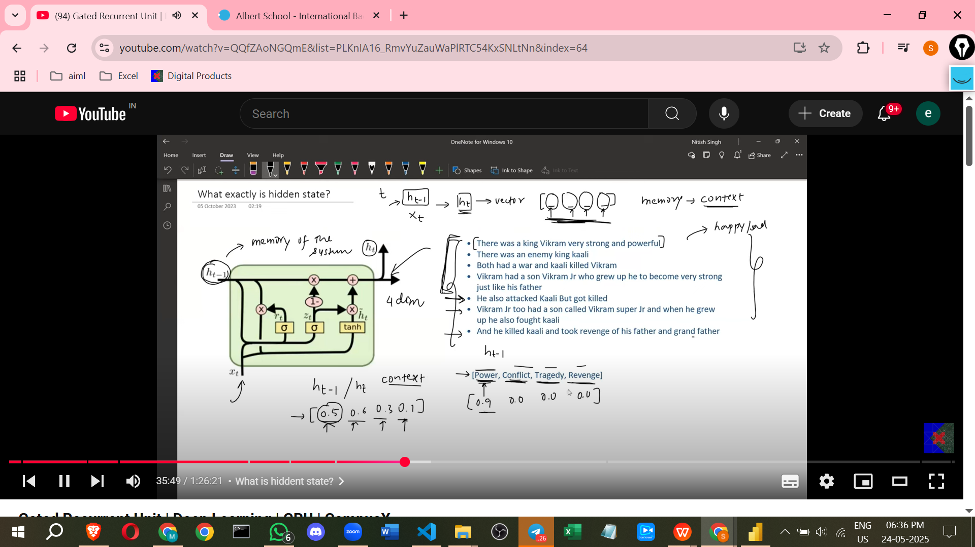



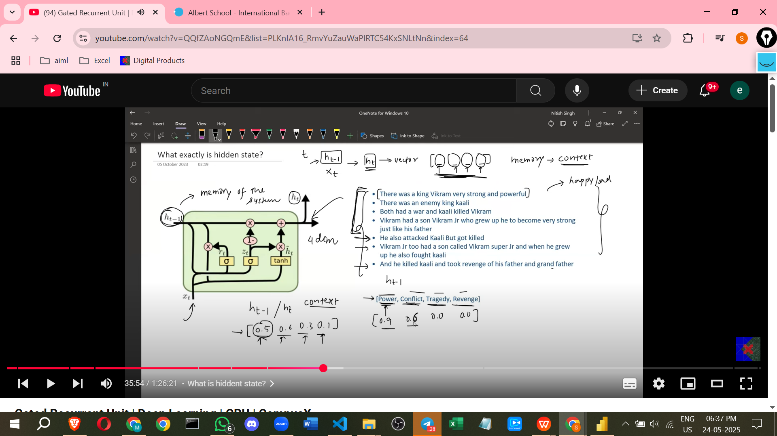

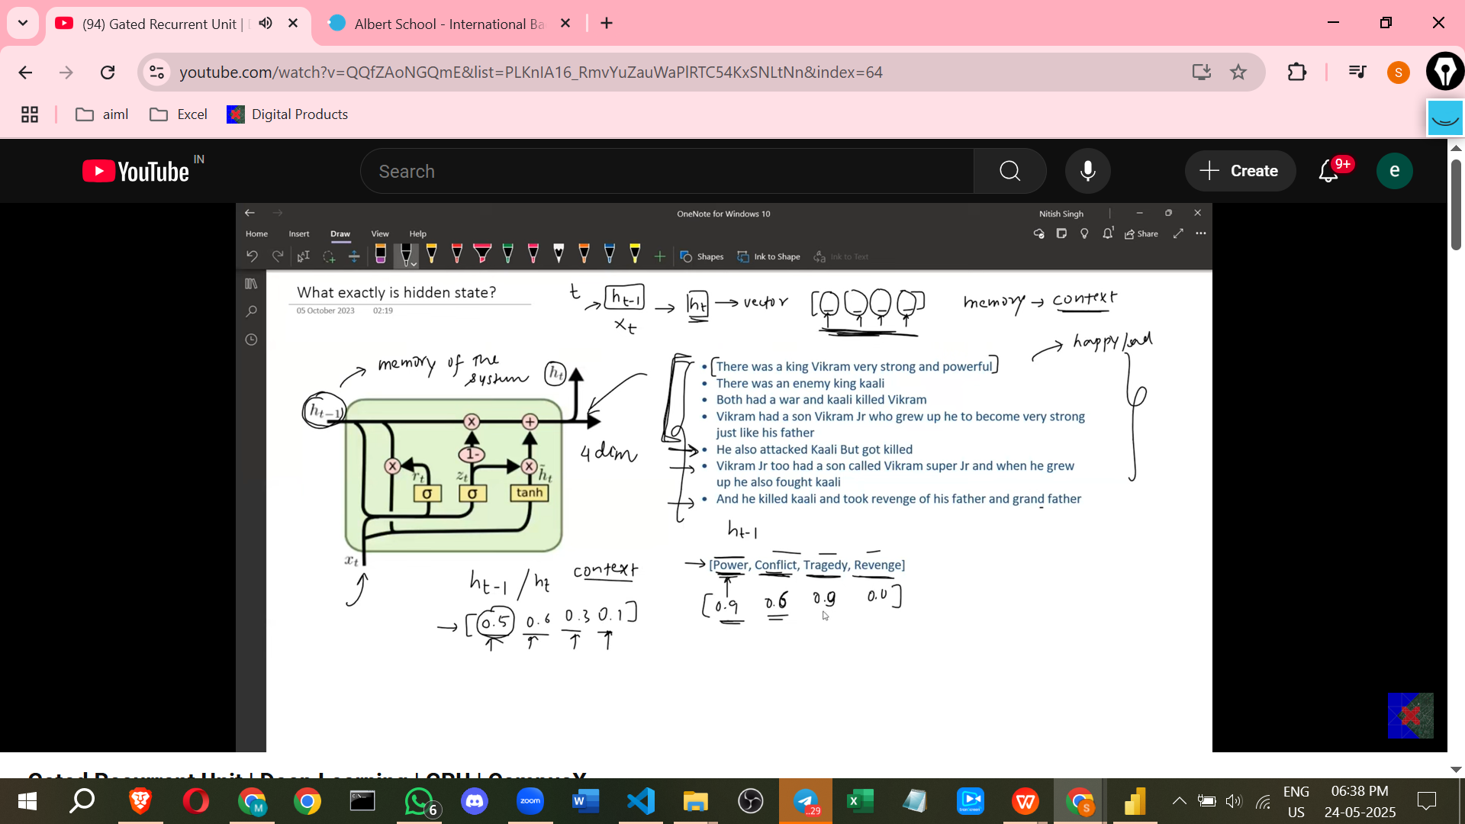

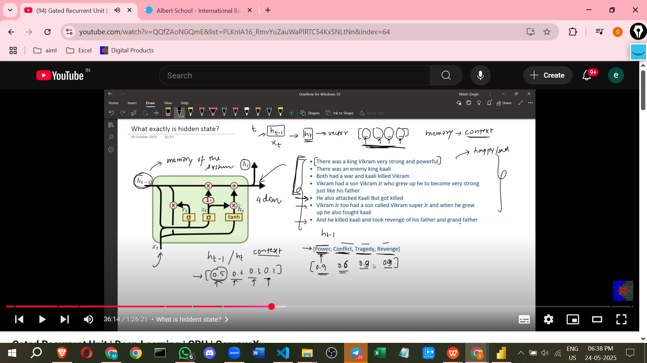

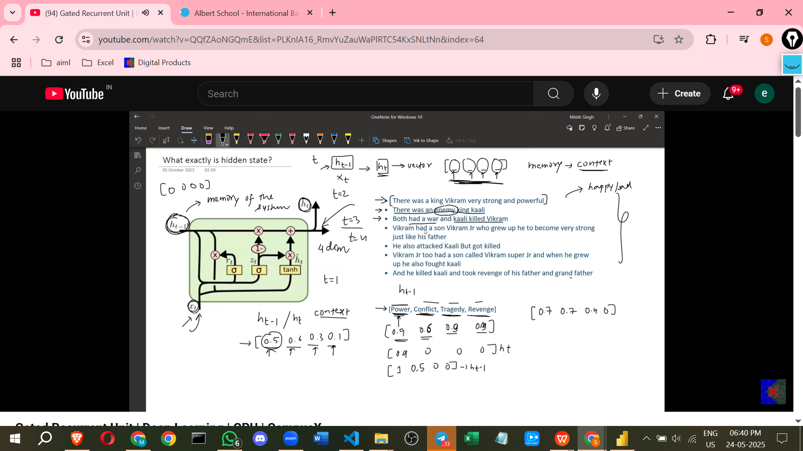

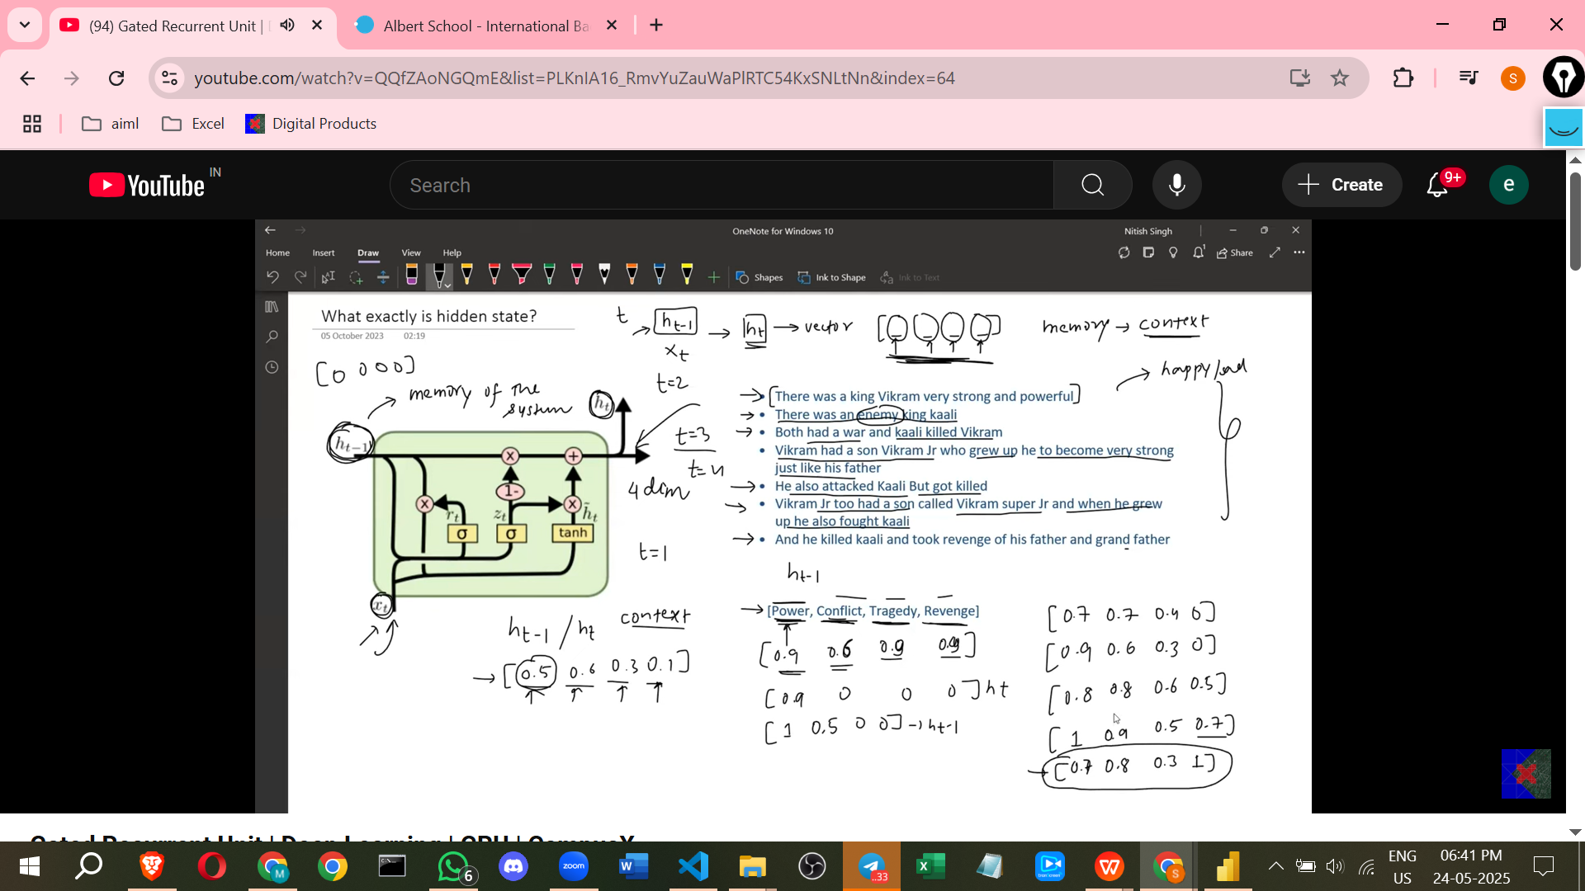

* Intuitively, the hidden state (Ht) represents the **memory or context** of the system at a given time step.
* When processing sequential data like text, the hidden state stores information about the preceding words or sentences.
* A hidden state vector, being a set of numbers, can be thought of as representing different **aspects or dimensions of the context** of the story or data being processed. (Note: While this story-based intuition is helpful for understanding, you cannot actually know what each number in the vector specifically represents in a real-world deep learning model – it's a black box).
* The numbers within the hidden state vector change over time as new input is processed, reflecting the evolving context of the sequence. These changes are driven by the gate mechanisms.

**The Two-Step Process for Calculating Ht**

The GRU calculates the current hidden state (Ht) from the previous hidden state (Ht-1) and the current input (Xt) in two main steps:

1. **Calculating the Candidate Memory (Ht-tilde)**: From the previous memory (Ht-1) and the current input (Xt), a **candidate memory (Ht-tilde)** is created. This candidate is a proposal for what the next memory *could* be, heavily influenced by the current input.

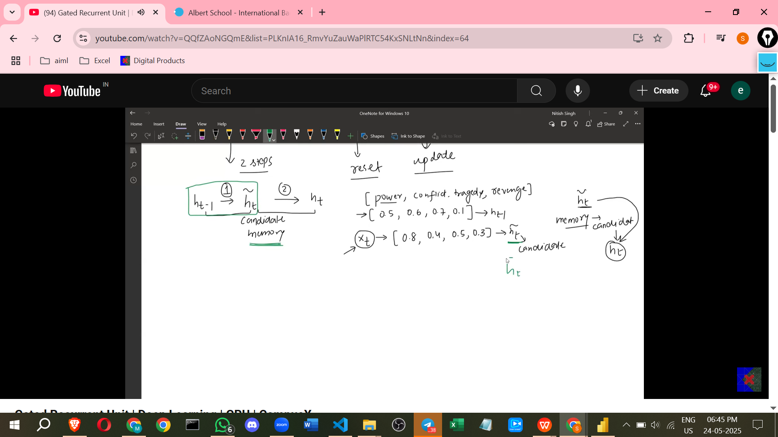

1. **Combining to Calculate Ht**: The candidate memory (Ht-tilde) and the previous memory (Ht-1) are then **combined or balanced** to produce the final current hidden state (Ht).

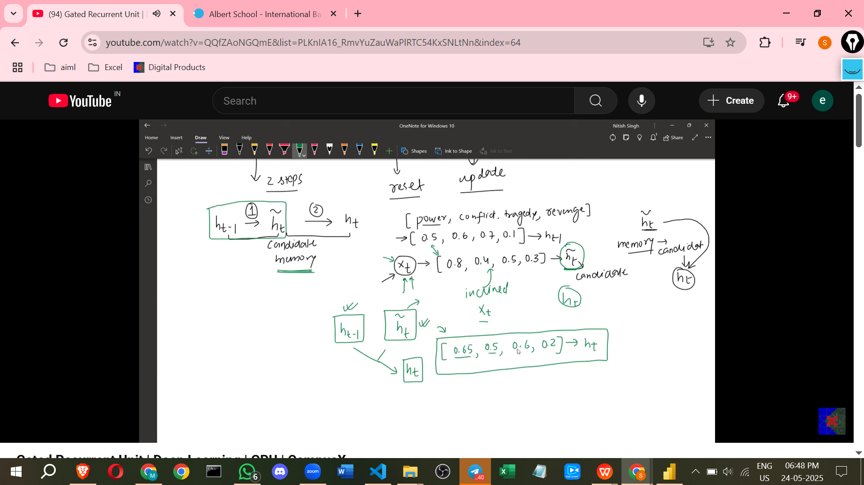

**The Role of the Gates in the Two Steps**

The gates control how information flows and how the memories are calculated in these two steps:

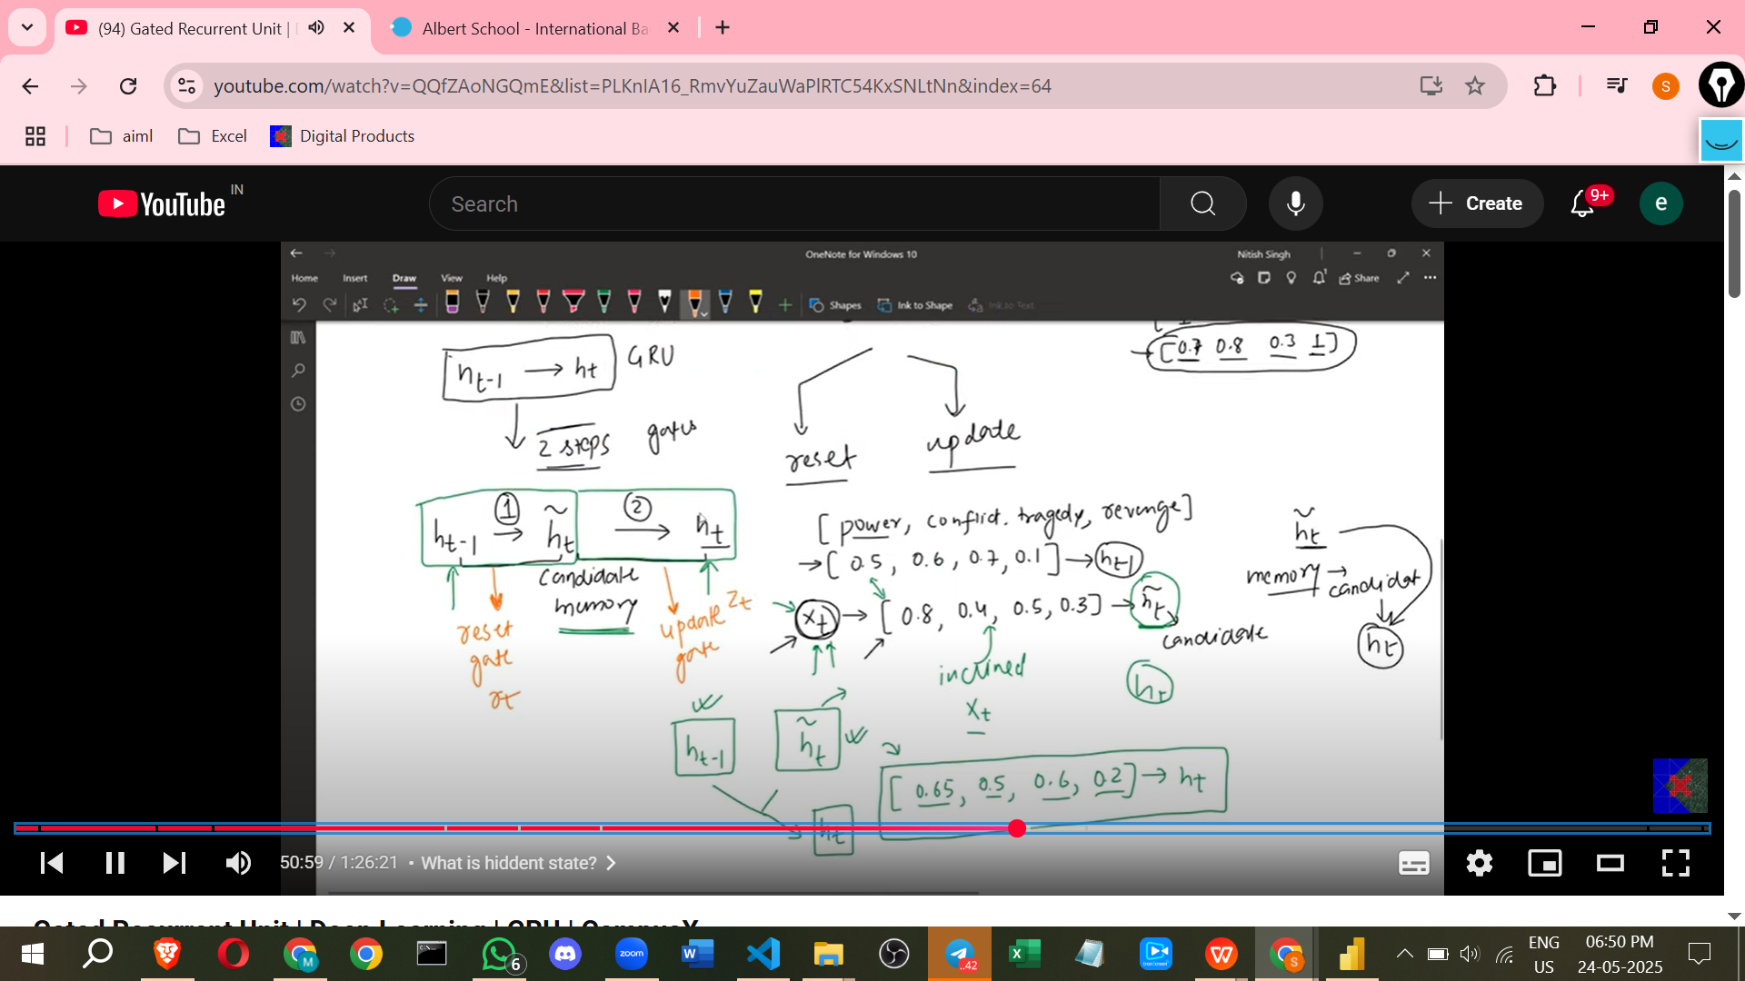

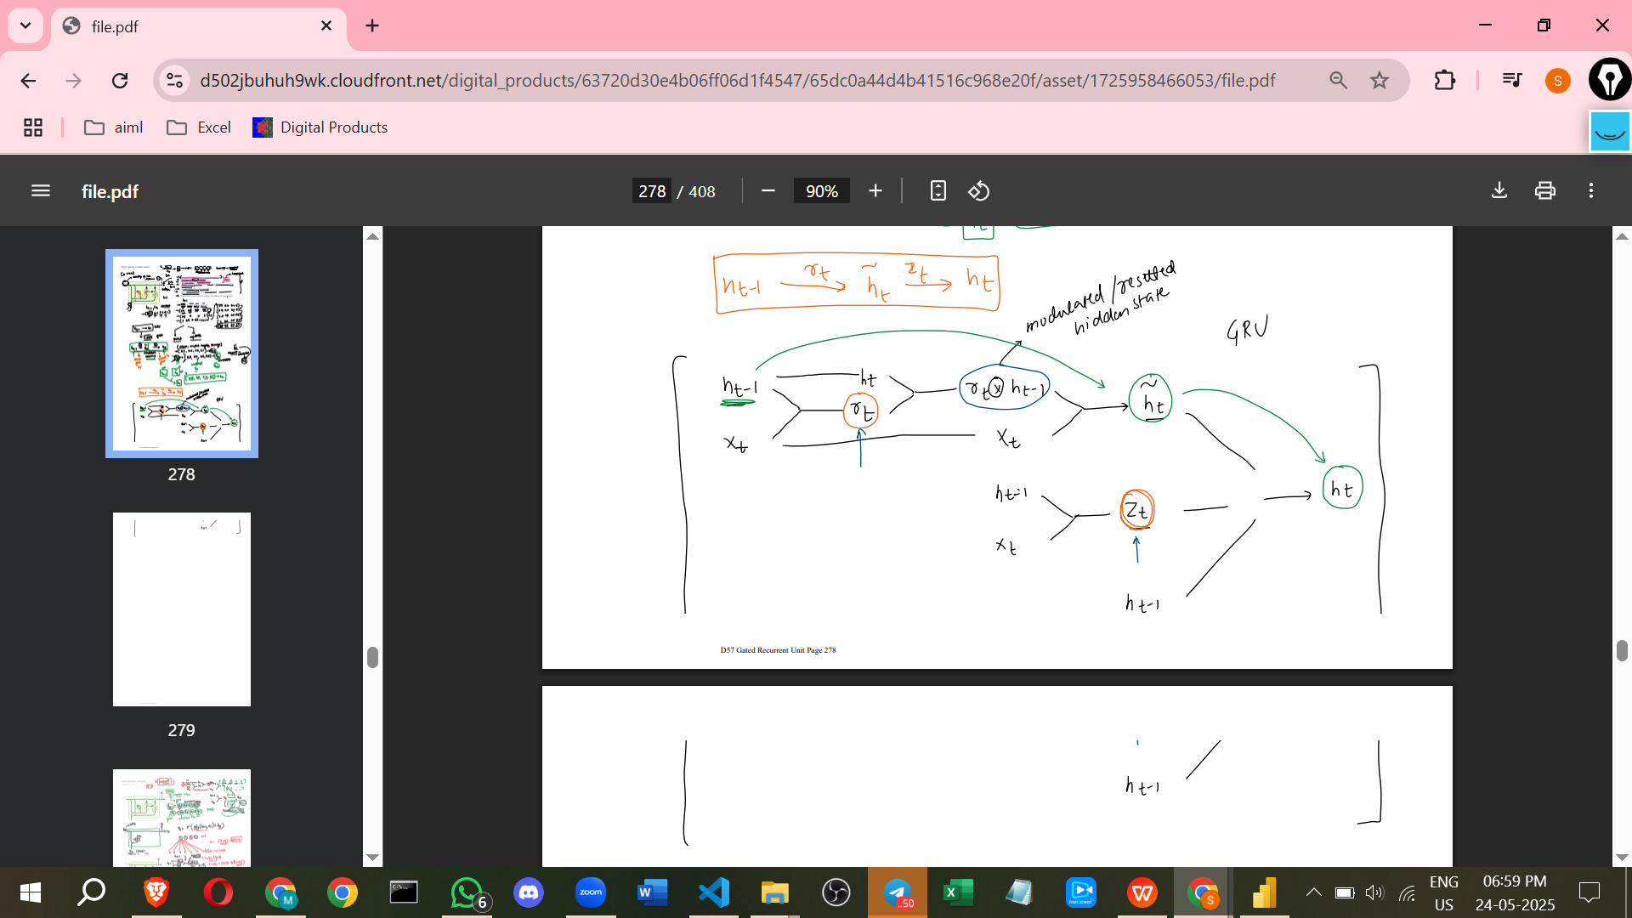

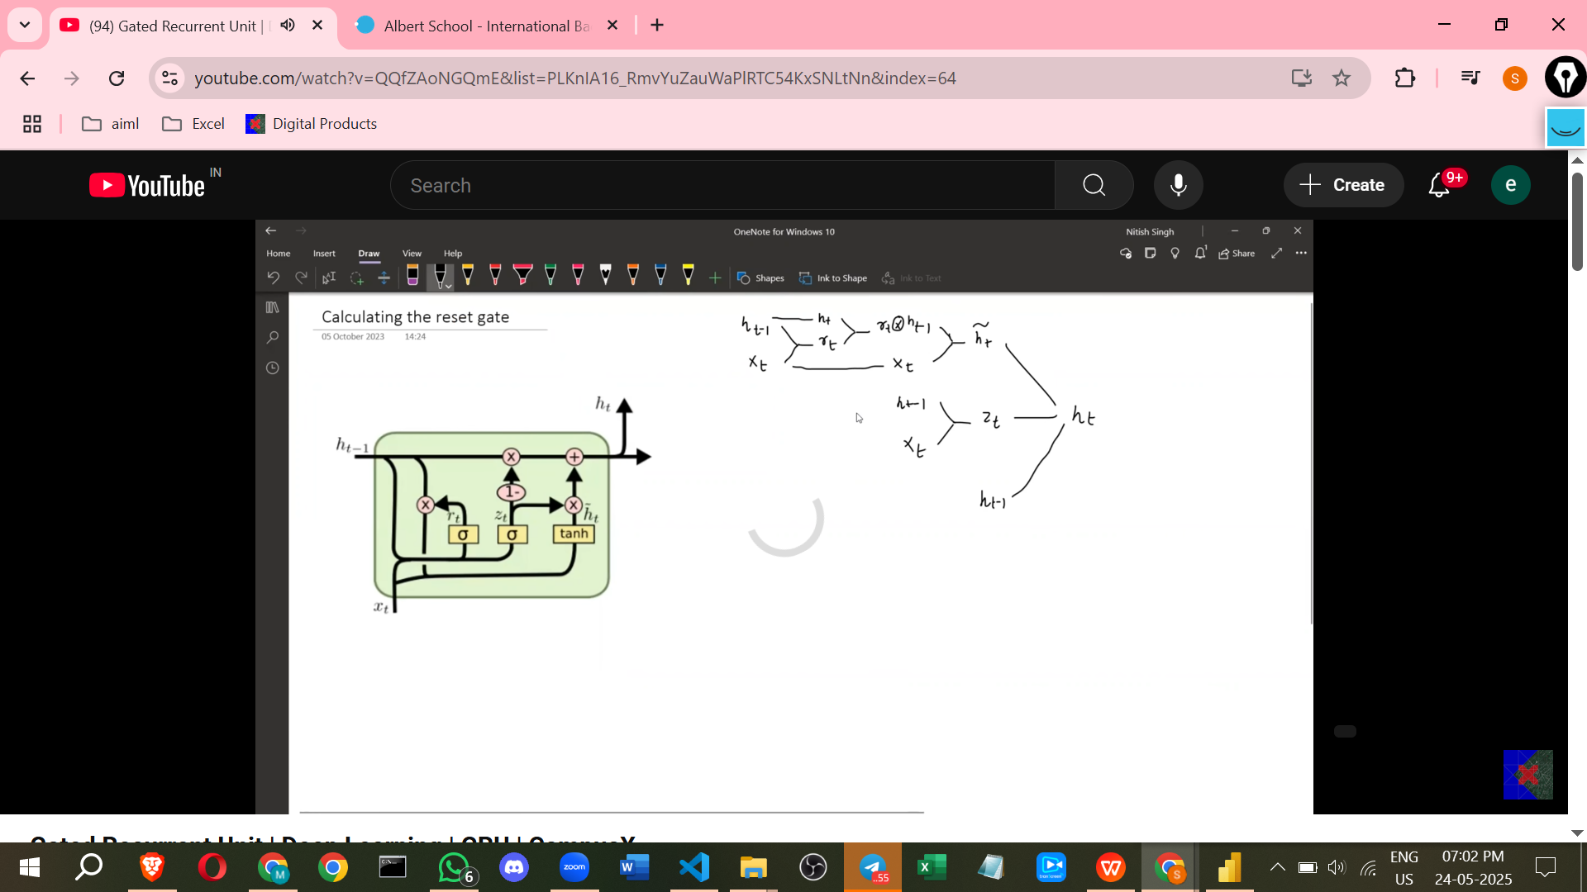

* **Reset Gate (Rt)**:

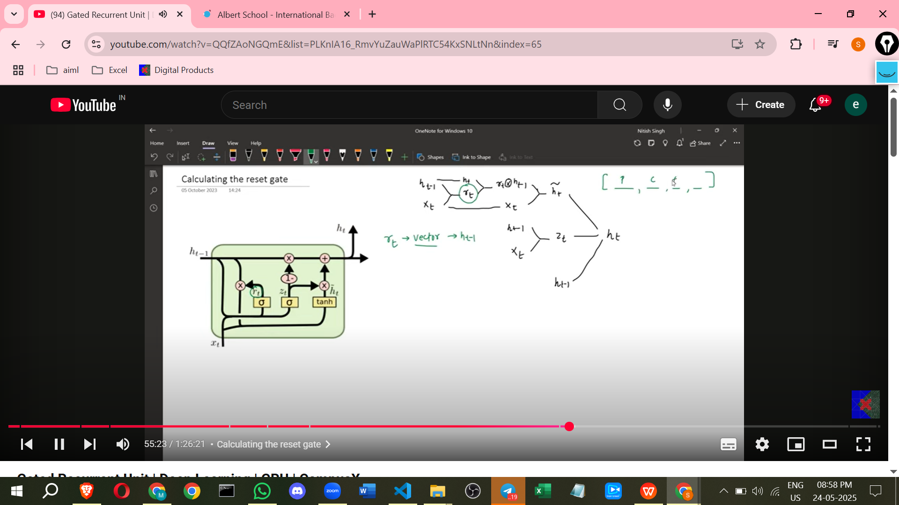

* + **Purpose**: The Reset Gate determines which parts or dimensions of the **previous hidden state (Ht-1)** are **relevant** to the current input (Xt) and should be **kept**, and which should be **reset or forgotten**.
  + **Calculation**: Rt is calculated by combining the pre

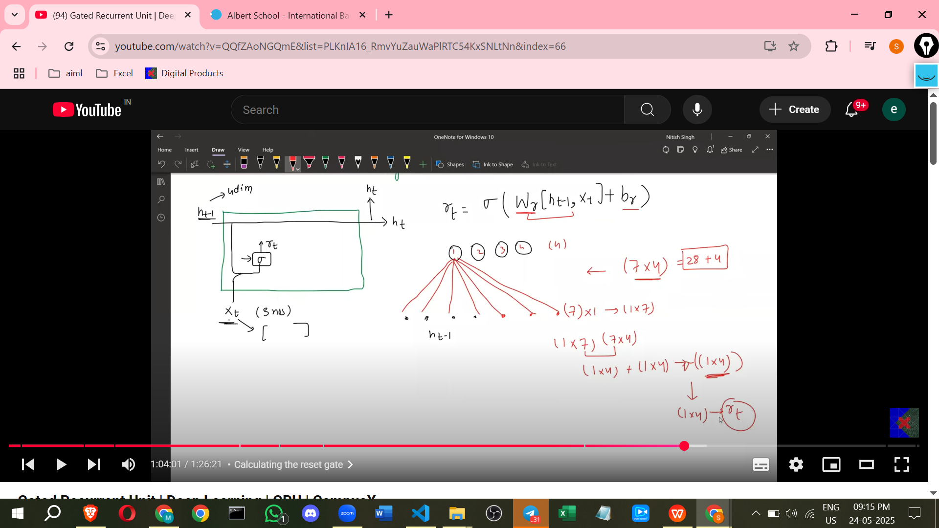

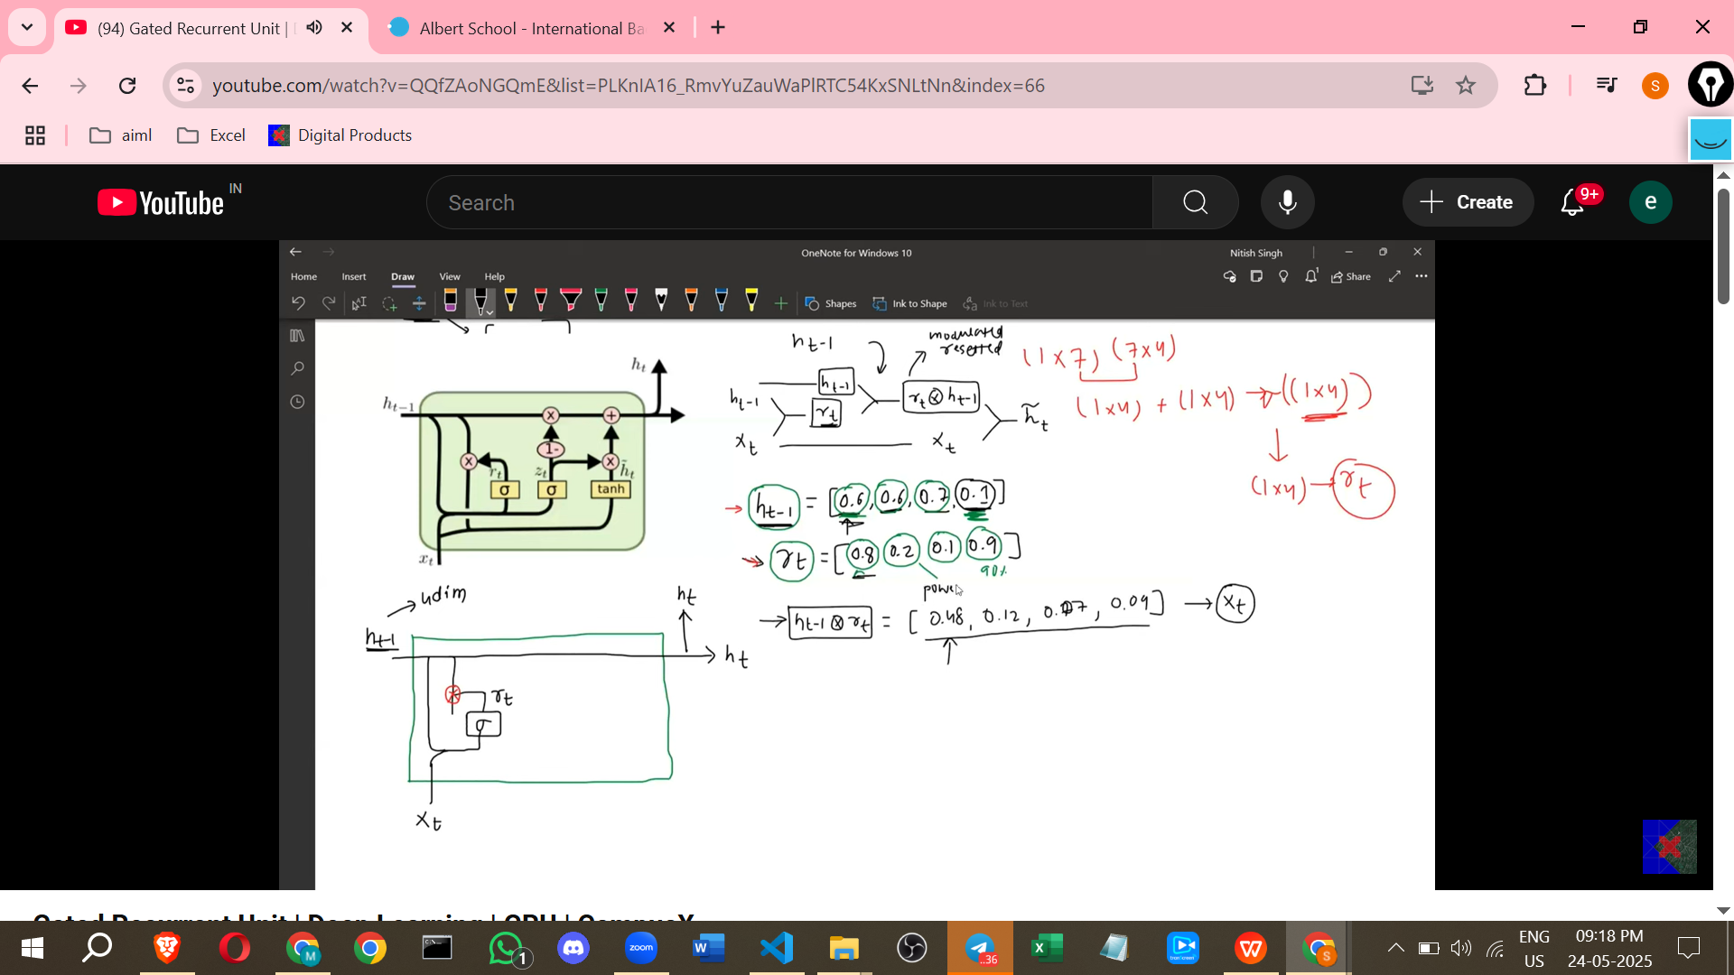

* + **Intuition**: If a value in Rt is close to 0, it means the corresponding dimension in Ht-1 should be largely ignored or "reset" when calculating the candidate hidden state. If it's close to 1, that dimension should be mostly retained.
* **Candidate Hidden State (Ht-tilde)**:

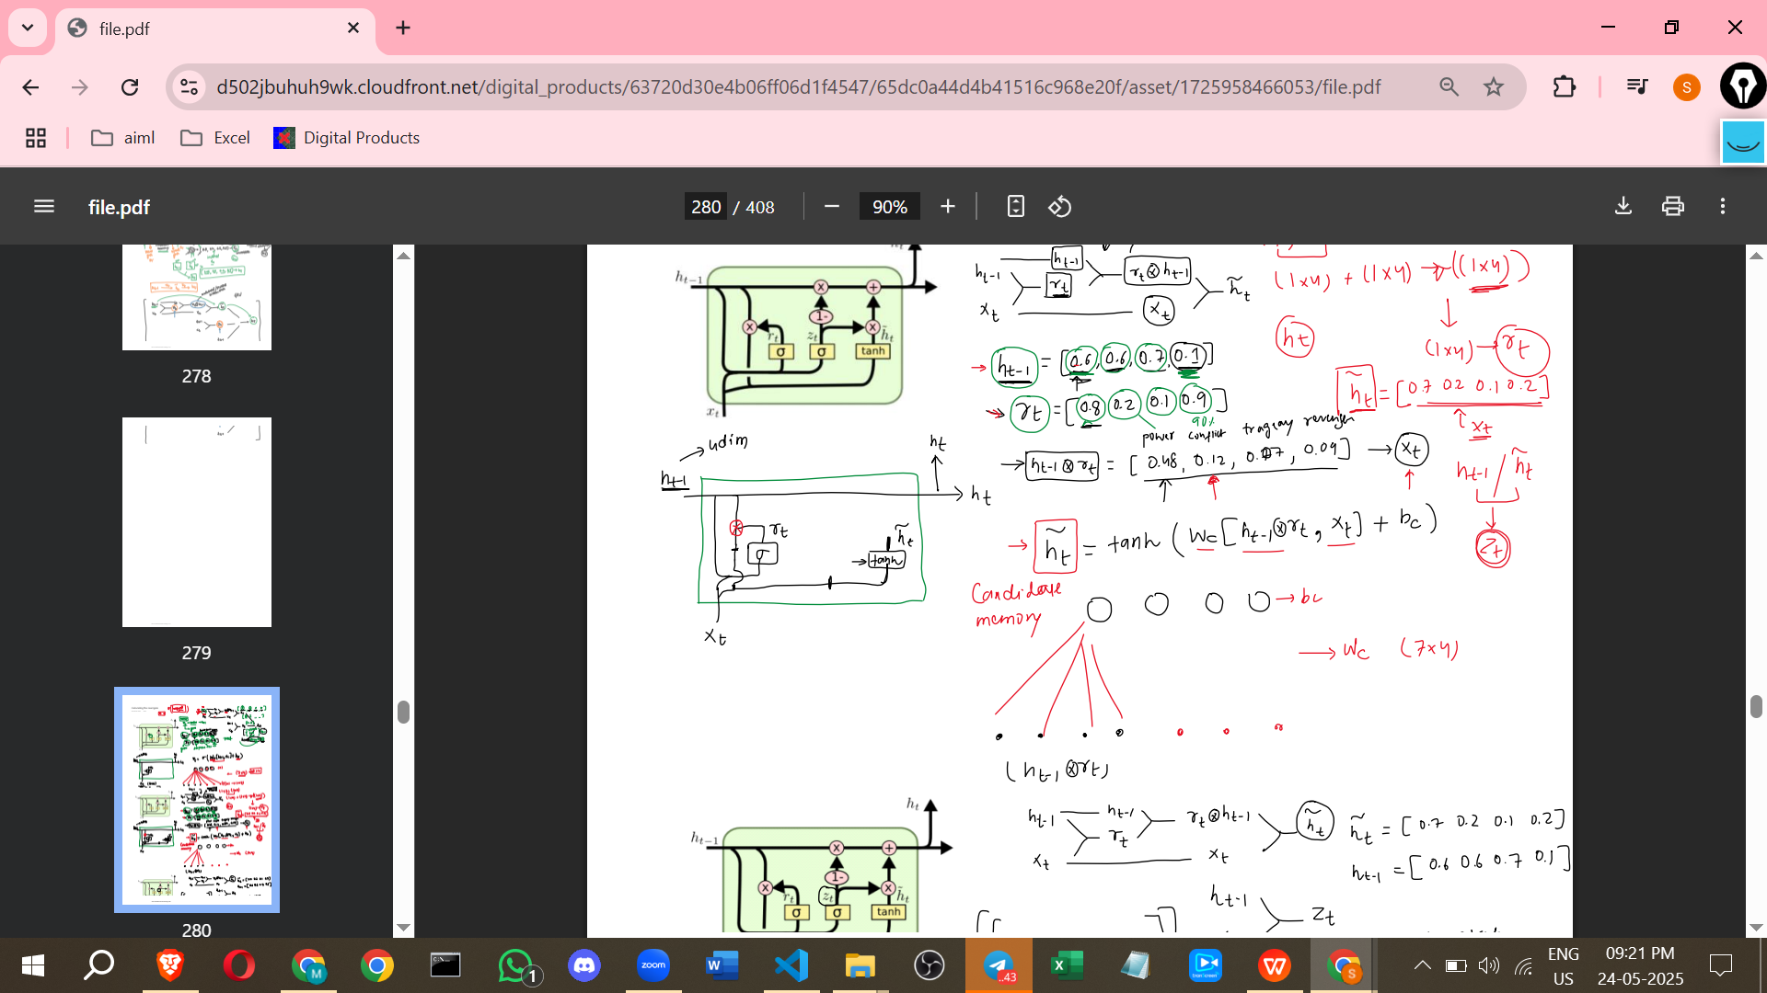

* + **Purpose**: Ht-tilde is a **proposed new hidden state** based on the current input and the *reset* previous hidden state. It's a candidate to become the next actual hidden state.
  + **Calculation**: Ht-tilde is calculated by combining the **current input (Xt)** with the **previous hidden state multiplied element-wise by the Reset Gate (Ht-1 * Rt)** and passing them through a **tanh layer**.
  + **Intuition**: This step merges the relevant parts of the old memory (as determined by the Reset Gate) with the information from the current input to create a potential new memory state.
* **Update Gate (Zt)**:

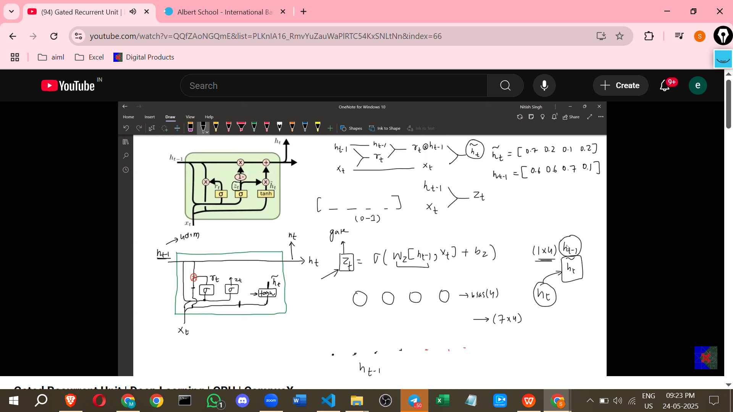

* + **Purpose**: The Update Gate determines the **balance** between the **previous hidden state (Ht-1)** and the **candidate hidden state (Ht-tilde)** when calculating the final current hidden state (Ht).
  + **Calculation**: Zt is calculated by combining the previous hidden state (Ht-1) and the current input (Xt) and passing them through a **sigmoid layer**. Like Rt, it's a vector with values between 0 and 1.
  + **Intuition**: If a value in Zt is close to 1, it means the model wants to heavily rely on the **candidate hidden state (Ht-tilde)** for that dimension (meaning the current input is very important). If Zt is close to 0, it means the model wants to largely keep the **previous hidden state (Ht-1)** for that dimension (meaning the current input is less important for that aspect of the memory).
* **Current Hidden State (Ht)**:
* 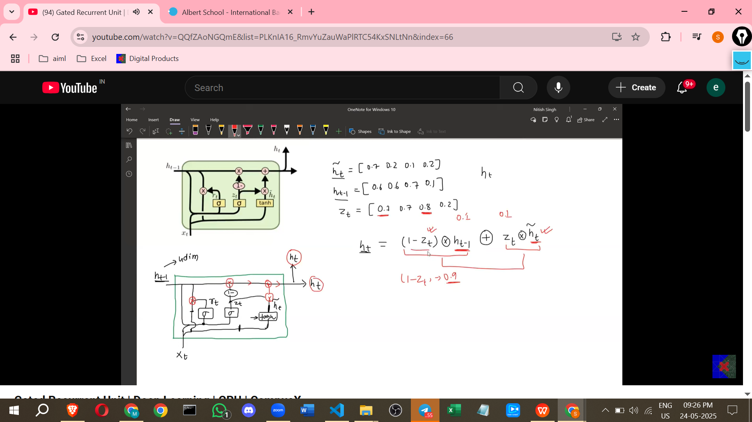
  + **Purpose**: Ht is the final memory/context state for the current time step, passed on to the next time step.
  + **Calculation**: Ht is calculated using a **weighted sum** of the previous hidden state (Ht-1) and the candidate hidden state (Ht-tilde), where the **weights are controlled by the Update Gate (Zt)**. The formula is: **Ht = (1 - Zt) * Ht-1 + Zt * Ht-tilde** (all operations are element-wise).
  + **Intuition**: This final step performs the balancing act. If Zt is high, the second term (Zt * Ht-tilde) dominates, incorporating more of the new candidate memory. If Zt is low, the first term ((1-Zt) * Ht-1) dominates, retaining more of the old memory.

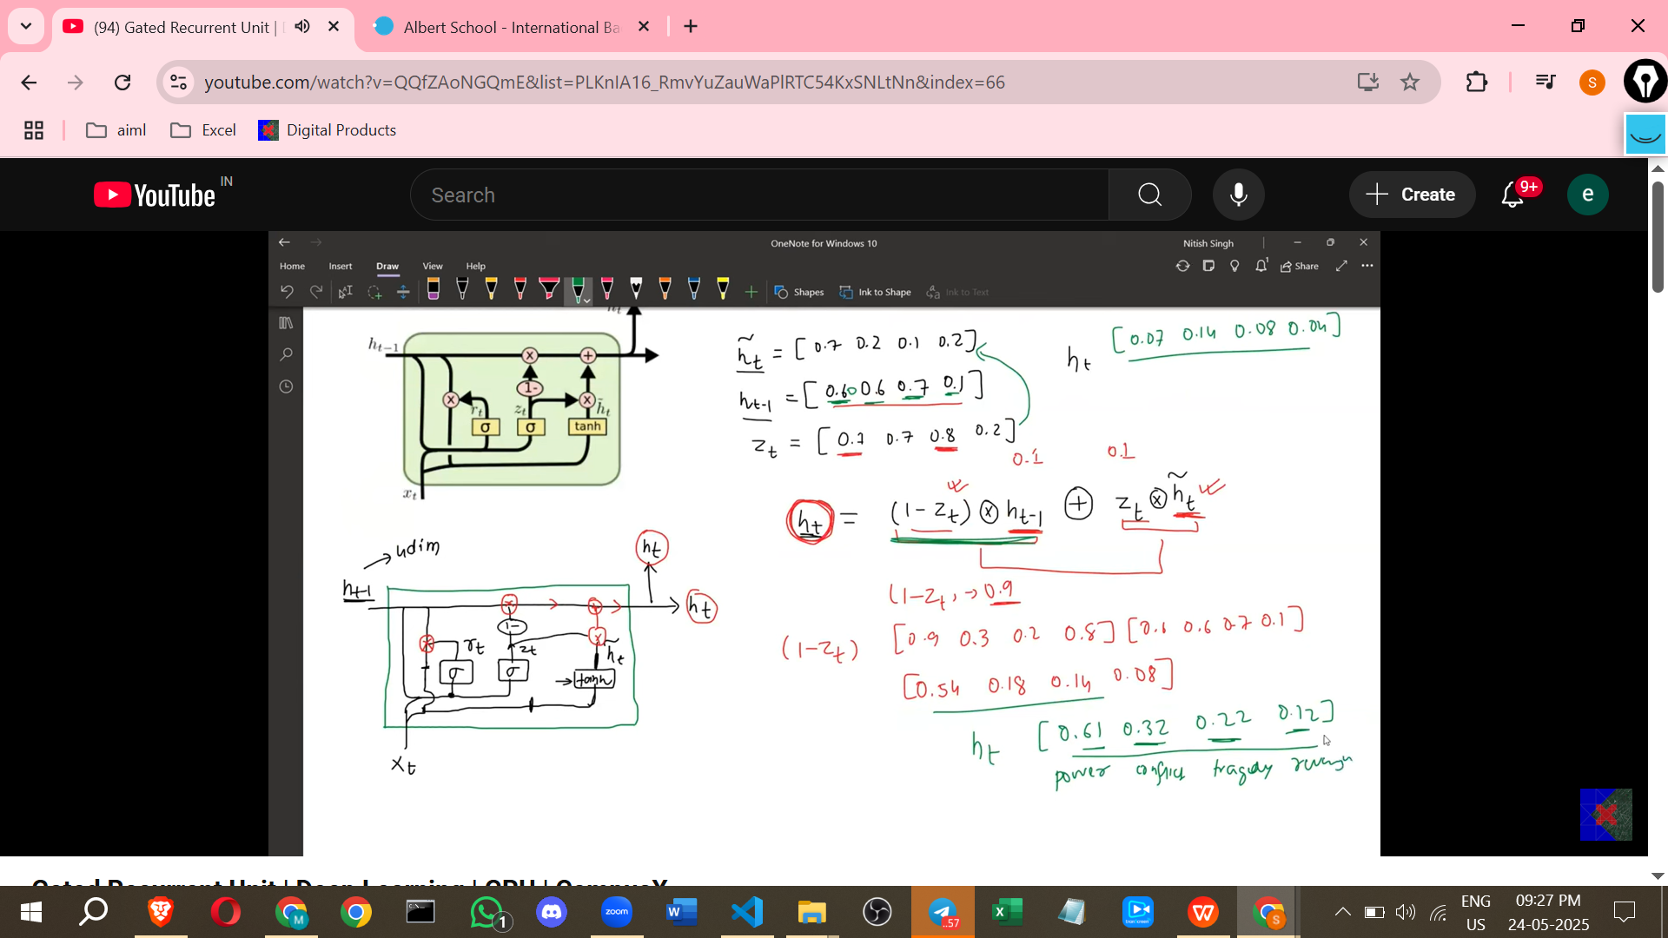

**Flow of Calculation (Summarised)**

1. Calculate **Reset Gate (Rt)** from Ht-1 and Xt (using sigmoid layer).
2. Calculate **Candidate Hidden State (Ht-tilde)** from Xt and the reset previous hidden state (Ht-1 * Rt) (using tanh layer).
3. Calculate **Update Gate (Zt)** from Ht-1 and Xt (using sigmoid layer).
4. Calculate **Current Hidden State (Ht)** by combining Ht-1 and Ht-tilde using Zt (using the formula (1 - Zt) * Ht-1 + Zt * Ht-tilde).

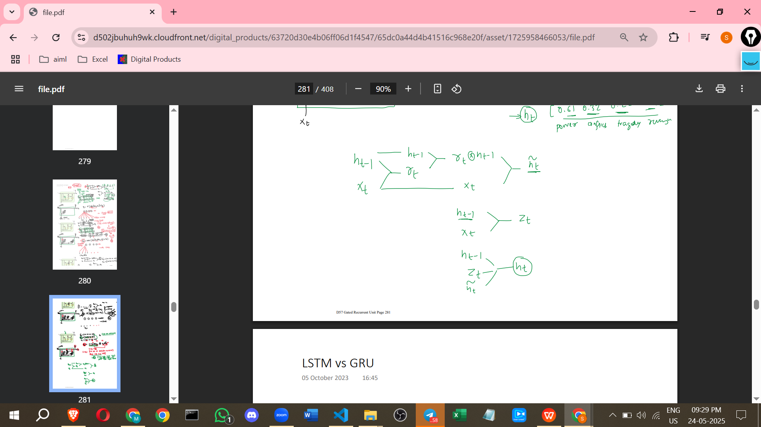

**Differences Between LSTMs and GRUs (Summary)**

| **Feature** | **LSTM** | **GRU** |
| --- | --- | --- |
| Number of Gates | 3 (Input, Forget, Output) | 2 (Reset, Update) |
| Memory Units | Cell State and Hidden State | Only Hidden State |
| Parameter Count | More | Less |
| Computational Cost | Higher, slower to compute | Lower, faster to compute |
| Empirical Performance | Often better on complex/large datasets | Comparable, can outperform on certain tasks/limited data, trains faster due to fewer parameters |
| Architecture | More Complex | Simpler |



**Additional Points for Learning the Concept (Information not from sources)**

* **Analogy for Gates**: You can think of the gate vectors (Rt and Zt) like a set of electronic knobs or switches. For each dimension in the memory vector, the gate value (between 0 and 1) acts like a knob setting how much of the information from that dimension is allowed to pass through or influence the next state.
* **Purpose of Sigmoid**: The sigmoid function outputs values strictly between 0 and 1. This is crucial for gates because we want to scale the information flow – a value close to 0 means block most of the information, and a value close to 1 means let most of the information through.
* **Purpose of Tanh**: The tanh function outputs values between -1 and 1. This is typically used for the candidate hidden state because it helps to normalise the values and can represent negative information, which can be useful in certain contexts within the vector representation.
* **Learning the Weights**: The neural network layers that calculate the gates and the candidate hidden state have associated weights and biases. These weights and biases are **learned during the training process** (e.g., using backpropagation) based on the data you provide. This learning process is how the GRU figures out *when* to reset certain parts of the memory or *how* to balance the old and new information for optimal performance on the task (like sentiment analysis or language modelling). The training adjusts the gate values and the candidate state calculation over time to best capture dependencies in the sequential data.